Bike repairing shop

Name
Registration number
Faculty
Course
Date

Bicycle repair and repair facilities are available, as well as services provided by a bicycle specialist. Self-help centers can be as simple as pneumatic air pumps, the most common and most expensive route in cities. They can be controlled by foot or the user's hand or with an air compressor. They are usually found in essential and safe places throughout the city, such as public transportation or business district, or next to an existing cycle infrastructure that supports a high number of bicycle vehicles, such as a highway cycle.
Repair equipment and bicycle hanging racks are available at state-of-the-art repair shops. Compatible services, such as drinking water and handwashing facilities, can be provided, making the repair area much easier to use. These self-service channels are metal boxes with tools inside. Because they are more expensive than air pumps, these artificial stations may no longer be widely distributed in cities as air pumps. Still, they will instead be available in easily accessible areas frequented by cyclists.
Bicycle specialists can offer repair and maintenance services at bike shops and dedicated repair stations. There is a high and focused service demand, which is often linked to large bicycle parking lots or multiple bike centers at Bike & Ride stations
Some repair and repair shops may provide a combination of automation and technical assistance if needed. Bicycle Kitchen in Malmö is where people can repair their bikes using garage tools while receiving instructions from garage workers or volunteers.
A government agency usually oversees the establishment and maintenance of free and fair public facilities for repair and maintenance. However, as mentioned earlier, buildings can be provided in privately owned bicycle parks or many bicycle parking areas. In addition, as the city's bicycle culture and population growth grow, the market will respond by increasing the number of private bicycle shops and services.
The repair shops are therefore required to be located in easily accessible places where the bike owners or the cyclist can easily access the places in the case of their bike getting some problems on their way. The bike repairing shops also needs to easily managed through a web based platform which is easy to use and that can be used by anybody to trace the nearest repair shop available. The repair shops should therefore be equipped well with all spare parts that a bike might need in case of the bike getting damaged. The bike repairing shops also needs to have qualified experts in the field of repairing the bikes. The individuals should also be many enough to handle several customers at a time to save on time which will make the customers happy due to the good reliable services they are receiving.
steps to follow when starting a bike repair shop:
You have found the right business opportunity and are now ready to take the next step. There is more to starting a business than just filing papers with the government. We have compiled this essential guide to starting a bicycle repair business. These procedures will ensure that your new company is well-organized, law-abiding, and well-registered.
Make a business plan.
As an entrepreneur, you need to have a well-thought-out strategy. It will help you to map your company information and discover the unknown. The following are points to consider:
What are the initial and ongoing costs?
What is your target market?
The optimal amount of pay to charge your customers?
What name will you give the shop?
What is the expense of beginning a repair shop?
Essential equipment (open locks, hex keys, screws, ratchet set, cord-cutters, flexible pliers)
Specific tools (wheel spoons, chain breaker, wheel pump, and pressure gauge, speaker screw, crank arm pulley)
Bicycle repair also requires workspace and special deals, but both costs can be kept to a minimum. Many bike repair shop owners start by repairing bicycles in their garage or basement, so they don't have to worry about renting costs until their business grows. Replacement parts are usually included in customer-indebted debt, and customers who need parts that are priced may be required to pay a deposit in advance. This type of deposit can be used to cover the cost of the required details.
the ongoing costs of using the bicycle repair shop?
The recurring costs of using a bicycle repair shop are minimal. They are as follows:
- Employee salaries.
- Renting an office space or in front of a store.
- Service costs
- Who is the target audience?
An avid cyclist who doesn't know how to repair their bike or doesn't want to put in the time and effort to do so is the ideal customer for a bike repair shop. Because they ride their bike regularly, such a customer will most likely require repairs and maintenance regularly, and they will be prepared to pay for the work their cycle necessitates.
the revenue model for a bike maintenance shop
A bicycle repair shop makes money by repairing bicycles and selling used bikes at a lower price. Many shops charge a set rate for tune-ups and then charge extra for subsequent repairs.
the maximum amount you can charge customers
Many bike repair shops charge Almost the same fee for basic tune-ups and charge an hourly rate for more complicated services. Wheels in Motion, for example, provides three levels of tune-ups, ranging in price from $79.99 to $214.99. Repairs that aren't covered by a tune-up usually are charged according to the parts and labor needed.
the most profit a bike maintenance shop can make
Some bike repair shop operators make as much as $35 per hour or more without adding any profit from parts sales. Entrepreneurs who turn their enterprises into full-time businesses might earn up to $1,600 each week.
How to increase the profitability of your company
Offering workshops on fixing bikes and repairing ancient bicycles can help bike repair company owners diversify their revenue streams and boost revenues. Some cyclists are willing to pay for a lesson that teaches them how to maintain and repair their bicycles. Refurbishing vintage bikes can also be profitable since they can be sold once fixed and are in good operating order.
Name to be given to the shop?
One needs to choose a good name for the shop. Choosing a good name is crucial to the business hence one needs to choose a right name which will be used to recognize the repair shop.
If you run a sole proprietorship, you should consider using a different business name than your own. For further information, see our DBA guide.When registering a business name, we recommend conducting the following research:
- The business records of your state
- Forms of federal and state trademarks
- Platforms for social media
- The existence of a web domain.

It's critical to get your domain name registered before someone else does.

Bibliography

Haine, Charles. The Urban Biking Handbook: The DIY Guide to Building, Rebuilding, Tinkering
with, and Repairing Your Bicycle for City Living. Fair Winds Press, 2011.
Pagliara, F., and L. Biggiero. "A survey on impacts of bike-oriented policies on residents and
economic activities." WIT Transactions on Ecology and the Environment 191 (2014): 749-756.
Collaku, Denise, and Nina Stojic. "BLVD Harambee Bike Shop

APPENDIX

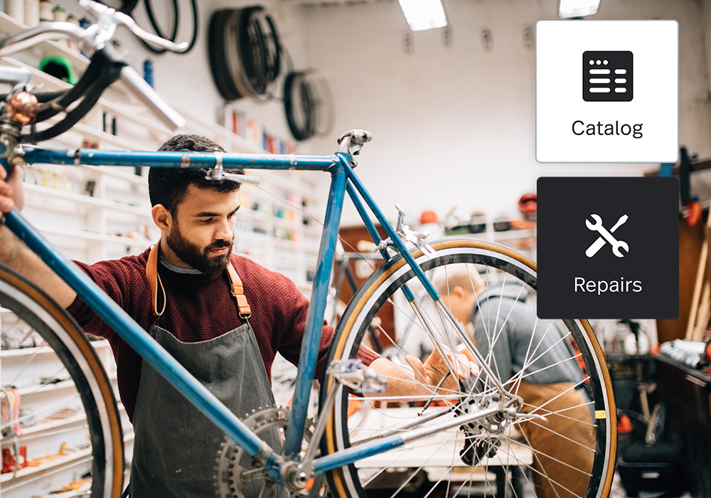
https://assets.lightspeedhq.com/img/52496ae0-t11745_retail-abm_module_bike_new.jpg

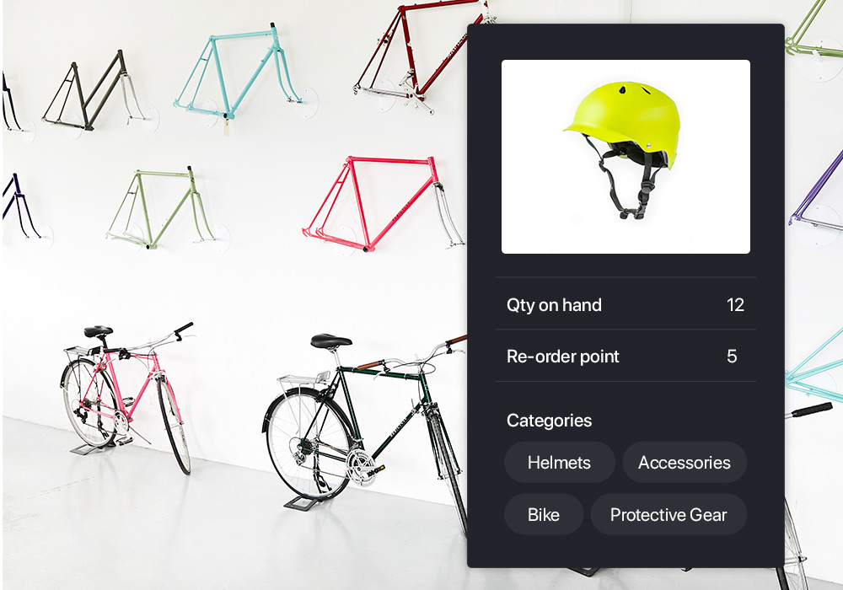
https://assets.lightspeedhq.com/img/2020/02/6c958e24-verticals_retail_bike_halfwidth-3.jpg

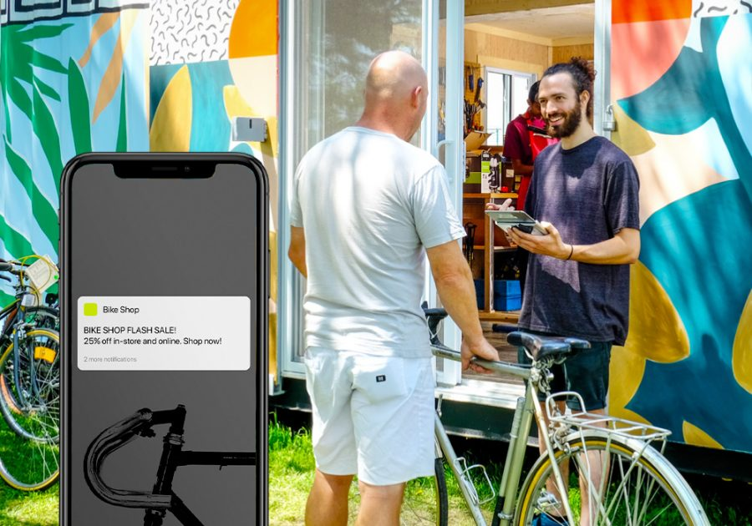
https://assets.lightspeedhq.com/img/a0262a6d-verticals_retail_bike_halfwidth-5-e1621020275437.jpg

Pagliara, F., and L. Biggiero. "A survey on impacts of bike-oriented policies on residents and economic activities." WIT Transactions on Ecology and the Environment 191 (2014): 749-756.
1 Pagliara, F., and L. Biggiero. "A survey on impacts of bike-oriented policies on residents and economic activities." WIT Transactions on Ecology and the Environment 191 (2014): 749-756.
Collaku, Denise, and Nina Stojic. "BLVD Harambee Bike Shop
Haine, Charles. The Urban Biking Handbook: The DIY Guide to Building, Rebuilding, Tinkering with, and Repairing Your Bicycle for City Living. Fair Winds Press, 2011.

